LEEDS CITY COUNCIL, DEPARTMENT OF EDUCATION

Beecroft Primary School,
Eden Way, Leeds, LS4 2TF

Telephone: 0113 2618820
Email: info@beecroft.leeds.sch.uk
Website: http://www.beecroft.leeds.sch.uk
Headteacher: Miss J Turner B.Ed. M.A.



__________________________________________________________________________
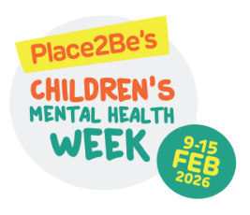

2nd February 2026
Children’s Mental Health Week 2025

Dear Parents and Guardians,

As part of our commitment to children’s mental health and wellbeing, we take part and celebrate Children’s Mental Heath Week each year. This year it will be taking place on Monday ^{9th} to Friday 13th February 2026.

This year’s theme is ‘This is MY place.’ Pupils will be studying belonging in class and thinking about how we belong and the impact that has on our thoughts and feelings.

As part of our celebrations, there will be a family assembly on Wednesday 11th February where children will share some of their mental health learning they have studied so far this year.

On Wednesday 11th February, Children are encouraged to bring any team uniforms or clothing that shows other clubs and communities they belong to- this could be a scouts/brownies uniform, a kit for a team they play for or cultural clothes. They will be able to change into them in class and present what they represent to others.

Thank you for your support,

Mrs S Carter

